**Assignment 4 Windchill  
1-Create Basic Life Cycle Template.**  
  
1) Login as Org Admin (Lastname_orgadmin) > Org-> Organization name >Utilities > Business Administration > Lifecycle template.  
  
2) Now select New Template from top left corner  
  
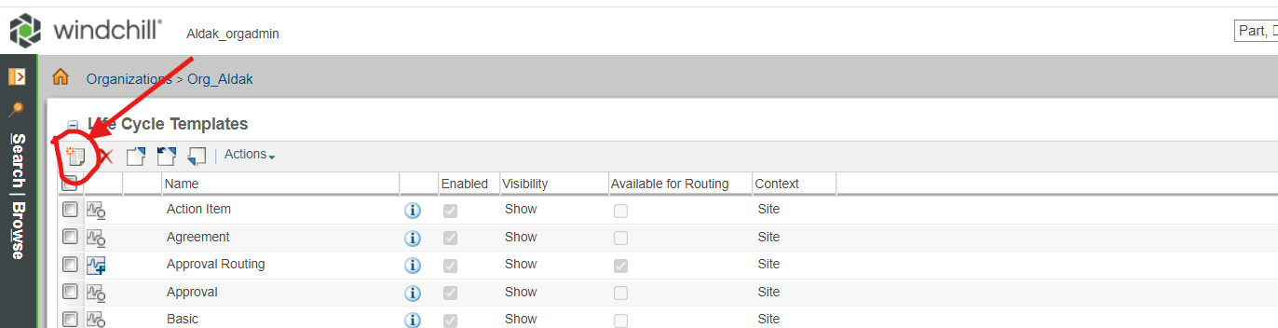  
  
3) After selecting the new template option one pop up will comes up like “ Do you want to run this application”. For this you have to select “Run”.  
  
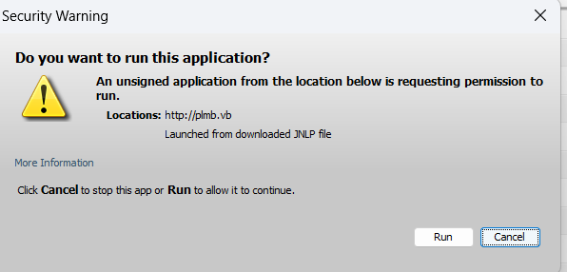

  
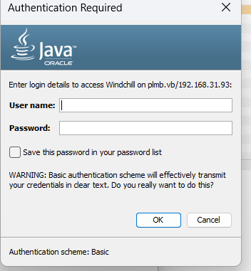  
  
5) Lifecycle window will open now choose Type Basic and select all the phases accordingly(from the top left corner)  
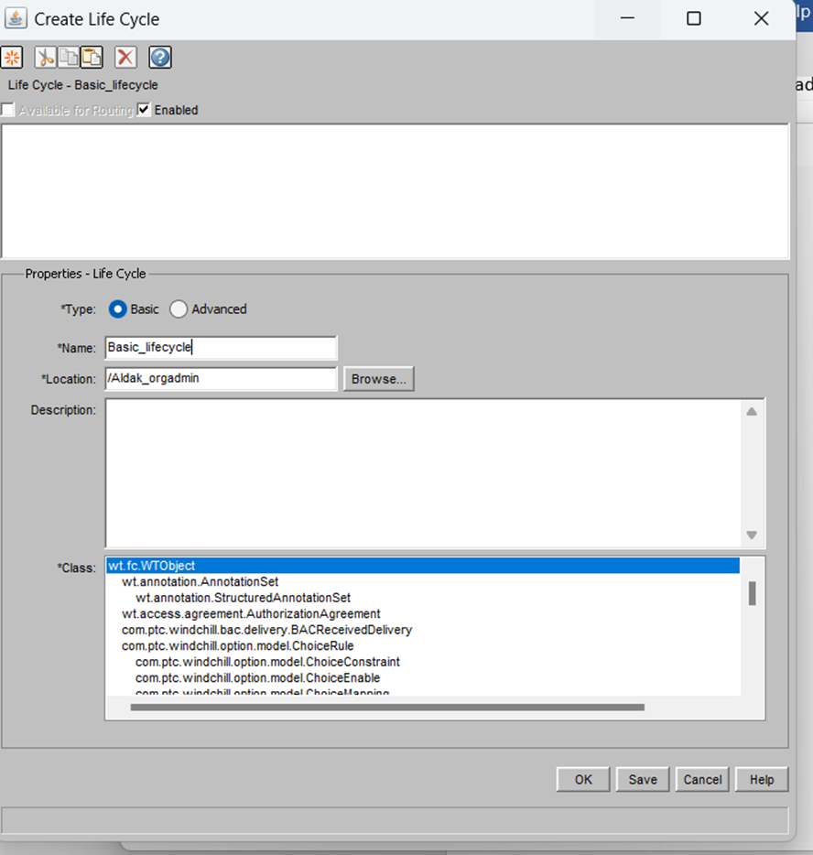

7) Save it here and refresh the Life cycle template tab.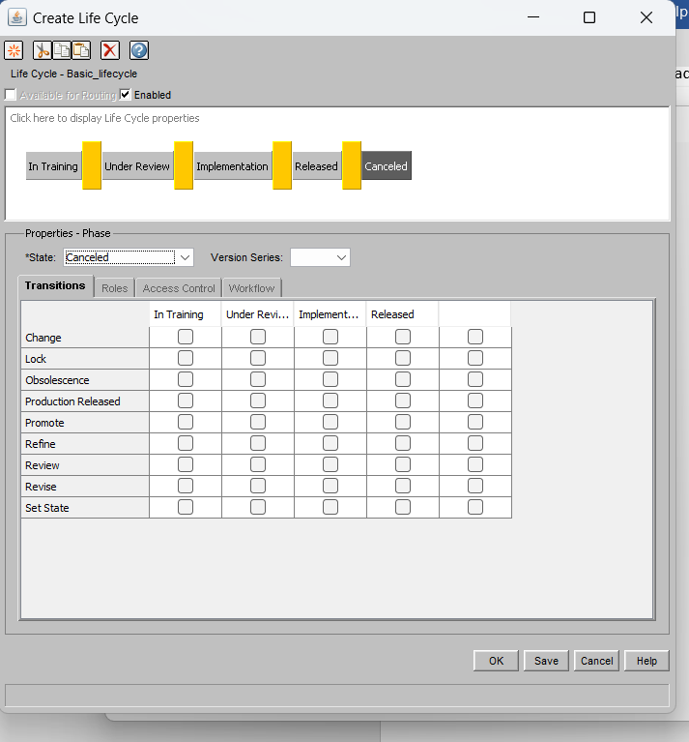

8) You can check the template that you have created, check in the template.  
  
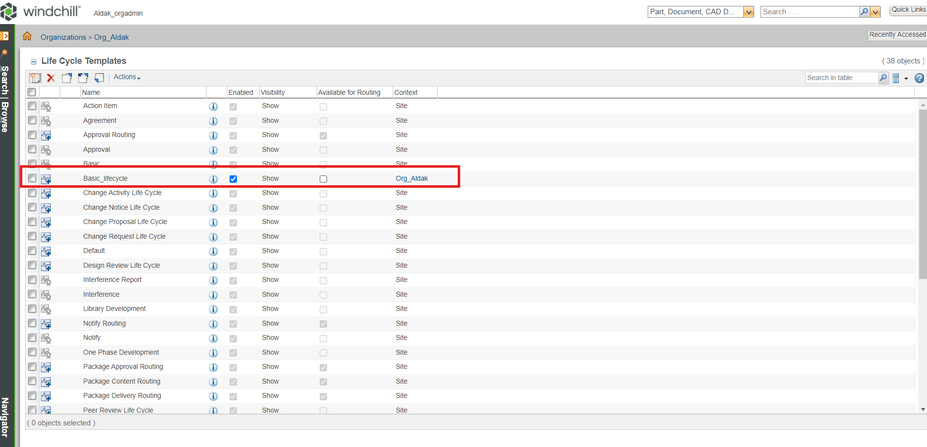  
  
  
  
9)Now go to Orgname > Utility > Object Initialization Rule > Select and download the part object xml file and edit the lifecycle name accordingly.  
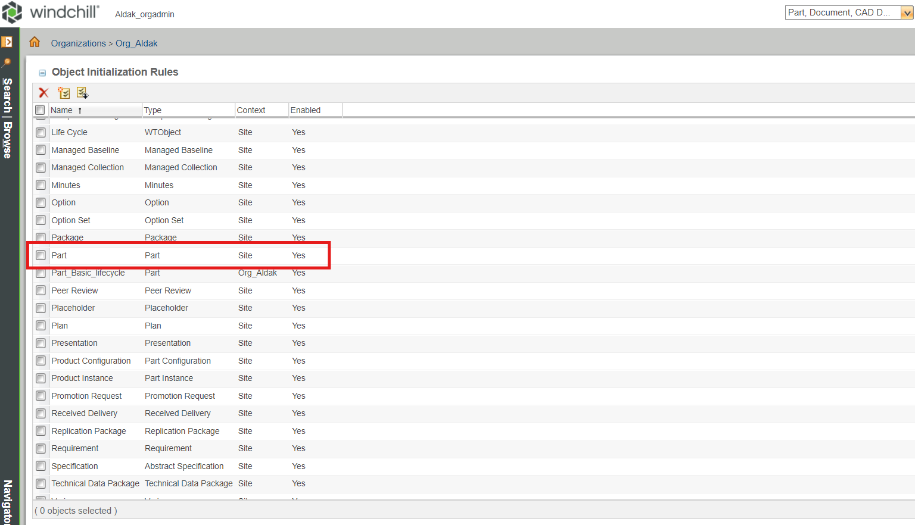

10)Save the OIR file after doing that(keep backup of original OIR)  
  
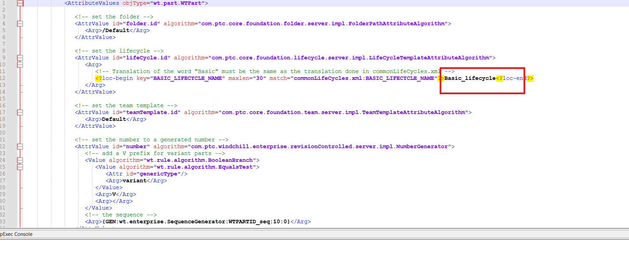  
11) Now go the OIR again and choose create new object rule and give any name , select part in type and attach the updated OIR xml file that you have saved recently.  
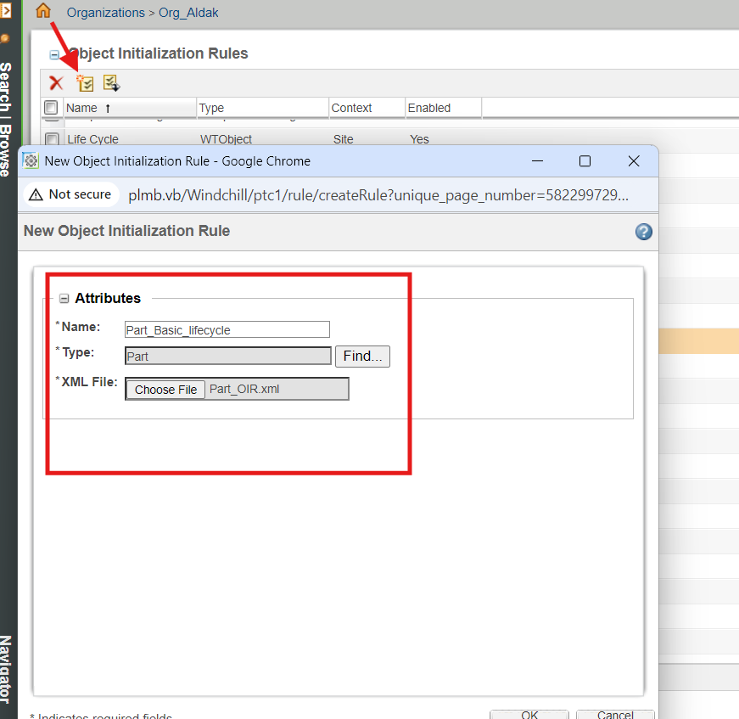

12) Refresh the OIR tab and you will find new part OIR.  
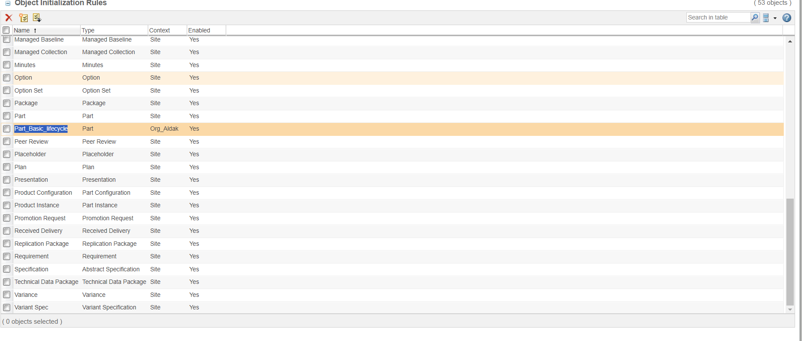  
13)Now login as a product user and create a new part there and check status of the created new part is changed as per our given phase requirement.  
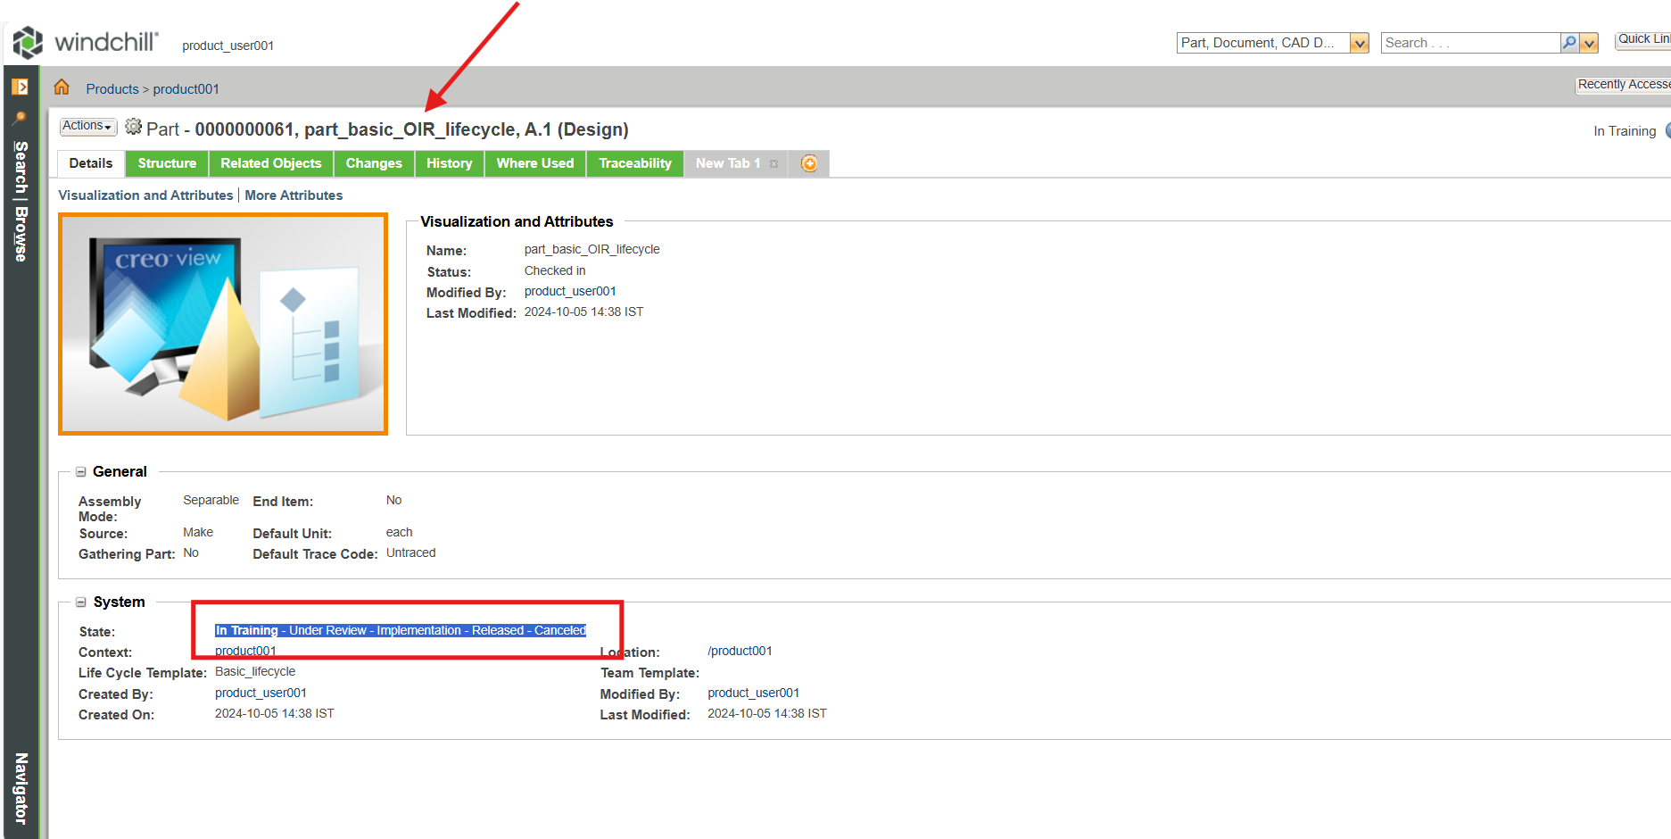

**Assignment 2 – Create workflow lifecycle template**  
1)Again login as a org admin > Org Admin (Lastname_orgadmin) > org >choose organization name > utilities >Business Administration > workflow template administration.  
  
2)Select new template and follow the same procedure for java applet as we used in assignment 1.  
  
  
3) New window will open for workflow > create workflow as per org requirement.  
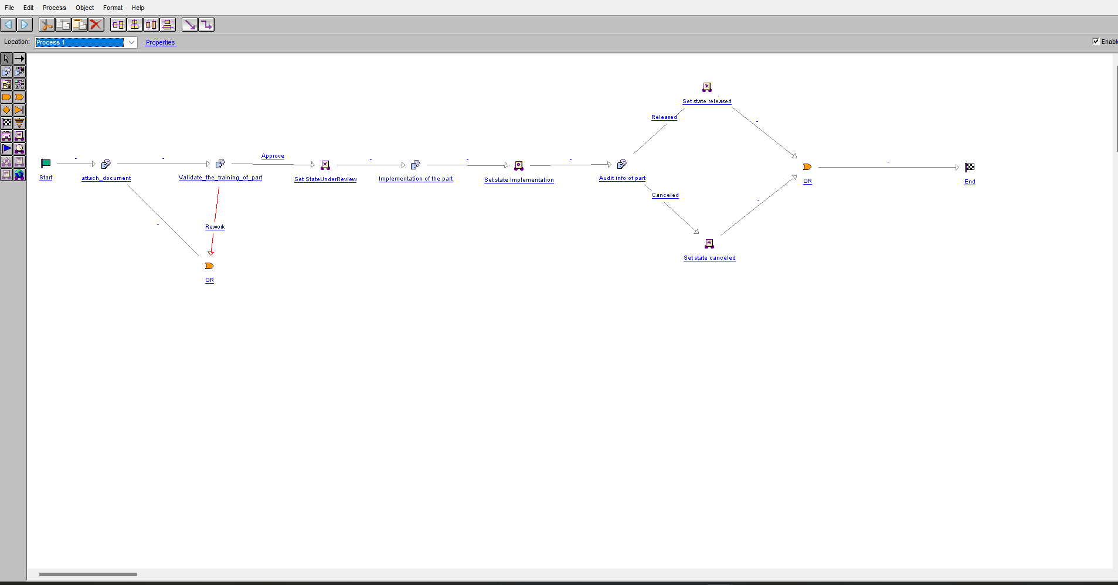  
  
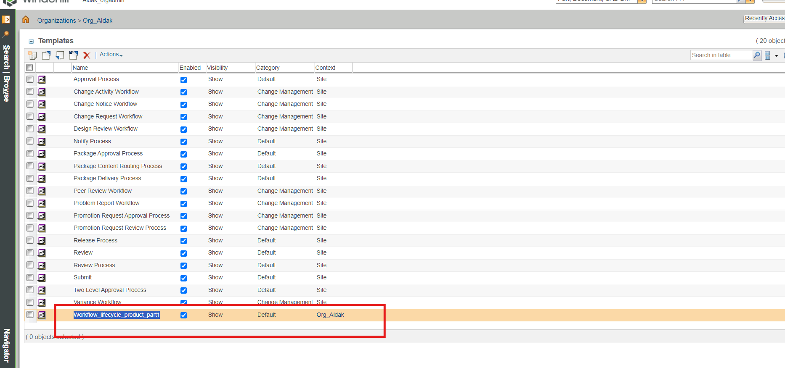

4) Follow the below steps as attached snaps  
  
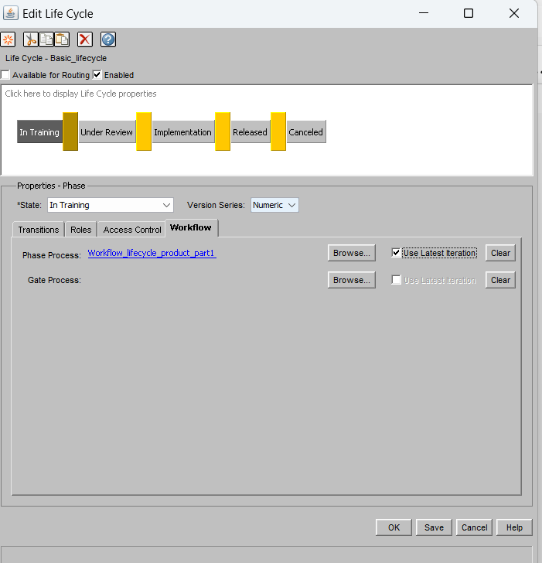



Login as product user,create new part and select new tab option available there and after that select customize >history > routing/process history  
